Reinforcement Learning HW 1

Section 2: Policy Evaluation

2.1
Because even in states where the policy is going up, since our environment is stochastic, there can be a probability of slipping and thus the expected discounted return accounts for these. So for these states there are nonzero chances of eventually reaching states 6 or 10 which propagate through the Bellman Ford equations.

2.2
Because state 1 is below the obstacle, but the action is UP so when it tries to go up, it will either be blocked/remain in the state or slip, with more risk of going to -1 or taking longer to reach +1. Meanwhile, state 4 could reach the terminal +1 state with less discounting/more easily than state 1 would.

2.3
Not directly what the optimal policy is, but we can see that the values are higher when closer to +1 region and lower when closer to -1 region, so the optimal policy would probably want to transition into the higher value neighboring states and avoid the paths that risk slipping into the −1 terminal state. However, to get the optimal policy we would want to do policy improvement/run value iteration.

Section 3: Policy Iteration

3.1
It took 3 iterations for the policy iteration to converge.

Section 4: Value Iteration

4.1
The action at state 7 changes from its initialized action 0 (north) to action 1 (east) at iteration 3

4.2
By iteration 3, the information of the +1 terminal state has propagated backwards enough through the grid, since state 7 is the top left corner and it would take 3 steps to reach that state and have received the discounted reward. Then at this point, the policy will flip because it is a better action and would receive a higher expected discounted reward.

Section 5: Effects of Time Horizons

5.1
This uses a higher discount, meaning it will prefer longer term rewards rather than immediate rewards. The agent has a longer planning horizon so the value of the further away states also increases as the optimal policy is more willing to take longer, indirect paths to reach the +1 terminal state.

5.2
In this policy, for example, for even states 1 and 2 the agent is less willing to take longer detours to avoid the −1 terminal or to plan far ahead. Compared to the previous examples with gamma = 0.9 and 0.99, this policy is a bit more conservative because the rewards that are further away may have less worth. Essentially the agent is more impatient and prefers short term rewards than long term, since the discount is a lower value of 0.75, the expected discounted reward is smaller for those actions.

Section 7: Convergence and Auto-Stopping Value Iteration
Gamma = 0.9
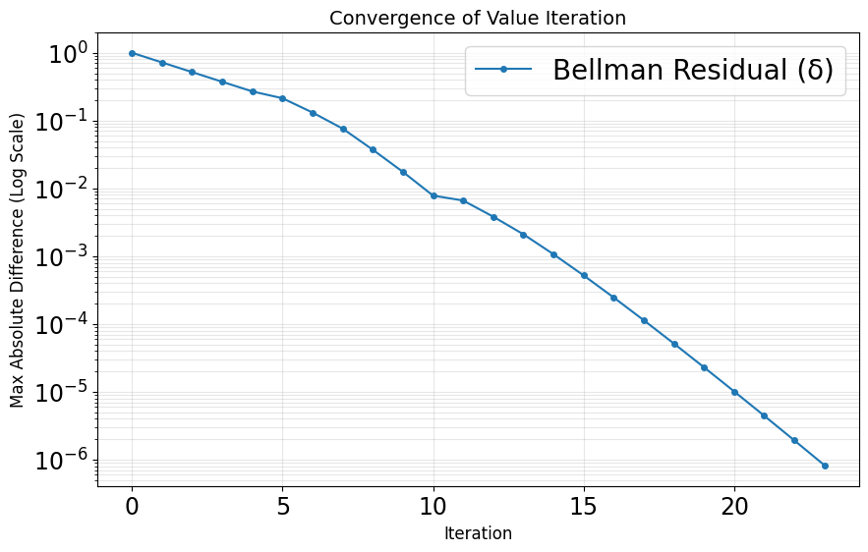

7.1
I tested the following values of gamma: 0.25, 0.5, 0.75, 0.9, 0.99. This showed that as gamma increases, the number of iterations it took to converge took longer. For reference, gamma of 0.25 took 10 iterations, with a larger difference between the delta and theta value, because the delta value was smaller. For comparison with gamma of 0.99 it took 106 iterations. As we increase gamma, the number of iterations increases but the difference between the delta and theta gets smaller as the theta value gets slightly larger.

7.2
That does not mean we have found the exact 𝑈∗ . It means that the value estimates are barely changing from one step to the next and the contraction property guarantees that those small updates mean the estimate is close to the unique fixed point 𝑈∗ while the error shrinks geometrically at a rate 𝛾 . Essentially, every update shrinks the distance between the current estimate and the true value function by a fixed factor.

Section 8

